**Chapter I**

**introduction**

## Background of the Study

The rise in the use of the internet has led to many changes in our daily life. In particular, this rise has also led to the rise of online gaming. Online gaming can refer to any type of game that someone can play through the internet or over a computer network. Most of the time, online gaming refers to the video games played over the internet, where multiple players are in different locations around the world. In most cases, online games are freeware programs that can be used for an unlimited time and are available for free. Most percentage of web games available nowadays is written in flash, shockwave and java languages. Because of that, they feature more primitive game play than downloadable games.

Having an online gaming experience typically requires a high speed internet connection. In terms of video games, online gaming is growing in popularity for variety of reasons. Gamers can easily find opponents of a similar skill level when playing a head-to-head game over the internet.

The researchers would like to develop an app for android to be able to provide an entertainment as well as learning that will keep the user continuously playing it. Most of the gaming apps of today’s makes use of the scoring, making the cutest outfits and changing it and makes challenge for the player to think and create moves from it. Quiz games are games that the player can gain knowledge from it. This type of games attracts the user because of the involvement of knowledge to those challenging question and entertainment to the user.

The study entitled “ARAZGA: A Mobile Based Arabic Quiz Game Application” is a game that not just only to entertain and challenge the gamers but also gain knowledge from it.

**Objectives of the Study**

***General Objective***

Generally, this study aimed to develop and evaluate a game application entitled “ARAZGA: A Mobile Based Arabic Quiz Game Application”. It is the kind of the game that will entertain the gamers as well as to gain knowledge about Islam.

***Specific Objectives***

**Specifically, this study aims to:**

1. **Allow players to register.**
2. **Provide menus (Start, Instructions, Settings, Help, Leader Board, Exit)**
3. **Manage configuration setting (Music/Sound. Background)**
4. **Provide mode (Play Solo**, Two Players).
5. **Set game categories (hadeeth, Seerah, Du’a, Qur’an)**
6. **Set game level (Easy, Average,** Difficult)
7. **Provide help(50/50, coins)**
8. **Provide leader board to show the top ranking players.**
9. **Automatically declare the winner for the two player mode after the game.**
10. Evaluate the game in terms of:
    1. Functionality
    2. Acceptability
    3. Aesthetic

## Significance of the Study

The study on the **“ARAZGA: A Mobile Based Arabic Quiz Game Application”** would be beneficial to the following:

**To the Players**

It would serve as entertainment and learning to the players for having knowledge about Islam.

**To the Researchers**

This study helped the researchers learn and get more ideas for their further studies .This also developed their writing, analysis and communication that is needed to conduct researches.

**To the Future Researchers**

This will benefit other researchers who wish to have similar studies as they can get background information from the results of this study which will serve as template to modify their research.

**Scope and Limitations of the Study**

This study aims to develop “ARAZGA: A Mobile Based Arabic Quiz Game Application” for gamers who are Muslims. This game helps to gain knowledge about Islam.

**When the player opens the application, the registration for player’s username would appear. After the registration, the main menu would appear such as; “Start”, “Instructions”, “Settings”, “Help”, “Leaderboard” and “Exit”. If the player clicks “Start” button, the option for “Play Solo” and “Two Players” would appear.** In “Settings”, the player can manage the Music, Sounds, and Backgrounds. The “Instructions” button shows the guidelines on how to play the game. The “Help” button shows the usage of lifelines and some tip in the game and the “Leaderboard” shows the top score of the player in every level. “Exit” button would close the game.

In the Play Solo mode, the four categories of the game would appear such as hadeeth, Seerah, Du’a and Qur’an. Each category has three levels of difficulties which are the easy, average and difficult. The players should select a category he/she wants to play.

In easy level, there would be 3 stages. It is a multiple choice format. Every stage has 10 questions. In stage 1, there are 30 seconds to answer for every question. While in stage 2 have 20 seconds to answer and stage 3 has 10 seconds to answer. Every 3 consecutive correct answer can collect 100 coins. The help would cost 50 coins. While the 50/50 help would eliminate the fifty/fifty words.

In the average level, there would be 6 stages. Each stage has 20 seconds to answer for every question. In this level, the answer would be given through scrambled letters. We provide 10 questions for every stage. The player should arrange the letters to form the correct answer. In stage 1, the scrambled letters is exact to the answer. If the answer has 5 letters, then the scrambled letters are also five. In stage 2, we add additional 4 letters. If the answer has 6 letters, then there are 10 scrambled letters because we add four letters in it. In stage 3, there are additional 6 letters which are scrambled. Stage 4 has additional 8 scrambled letters. Stage 5 has additional 10 scrambled letters and Stage 6 has 12 additional scrambled letters. Every correct answer has a score of 2. The help would cost 50 coins.

In the difficult level, there would be 10 stages. The type of the game would be word banking. It is like a family feud wherein the player would guess the answer and has a point. The top answer has the highest point .Each stage has 30 seconds to answer. In stage 1, there are 3 words that the players that the player needs to guess in 30 seconds. For example the question is “Give at least 3 names of Allah” then the player needs to answer it in 30 seconds. In stage 2, we add 4 words. Stage 3 has 5 words. Stage 4 has 6 words. Stage 5 has 7 words. Stage 6 has 8 words. Stage 7 has 9 words. Stage 8 has 10 words while Stage 9 has 11 words and Stage 10 has 12 words.

In the Two Players mode, the host needs to get first the IP address of the player. The host would choose the type of game such as the multiple choices, scramble letters, word bank. The game would start if the player already tapped the ready button. The game would provide 50 questions to be answered by both players. There would be no lifelines. The game would automatically end if both players already finished answering 50 questions and the scores of both players would be displayed throughout the game. The player who gets the most correct answer would win the game. A dialog box would appear to the player’s screen either you win or lose. It would return to the main menu.

## Operational Definition of Terms

The following terms were operationally defined as used in this study:

**Dua’a -** is an act of supplication. The term is derived from the Arabic word meaning to ‘call out’ or to ‘summon’ and Muslims regard this as a profound act of worship.

**Hadeeth -**  the record traditions or sayings of the

prophet Muhammad revered and received as

a major source of religious law a moral

guidance, second only to the Quran.

**Islam -**  is a religion of Muslims.

**Muslim -** is person who believes in Allah and believe in the teaching of the teachings of Islam.

- is the holy book of Muslims, revealed in aghanstages to the prophet Muhammad qur’anic revelations are regarded by Muslim as sacred word of God.

**Qur’an**

**Seerah**  - are the traditional Muslim biographies of

Muhammad from which in addition to the Quran

and Hadeeth. Most historical information about his life and the early period of Islam is derived.

**Chapter II**

**review of related literature**

This chapter presents the related literature and studies that helped the researchers in the conduct of the study.

***Related Literature***

Play is a powerful influence on learning that is fundamental to the life of adults and children. Spreading the Islamic words and help them to develop their knowledge about the words of God.

The use of games for children and adults alike are a great way to improve a great number of mental and physical skills, and often bring with them a lot of significant benefits. Games have a fear greater educational influence than most people are aware of. Many children with developmental disabilities, who don’t normally seem to react to their environments are often completely transformed when playing games.

**Related Studies**

**Who wants to be a Millionaire?**

Is a British television quiz show that offers a maximum cash prize of one million pounds for correctly answering successive multiple-choice question of increasing difficulty. One contestant played at a time and originally had no time limit to answer question. Contestant were presented with the question and possible answer before they decided whether to attempt an answer, use one of their lifelines (50:50, Ask the audience or phone a Friend (or later on, Switch)), or walk away with what they have already won. One of the most significant shows in British popular culture, it was ranked 23rd in a list of the 100 Greatest British Television Programmes.

Most of the present crowd sourcing application asks the participants to answer open ended question and there has been a little work on using multiple choice question answering (MCQA) for crowd sourcing. However, asking multiple choice question facilities human collaboration and their answer are easier to aggregate. We present a detailed investigation of the factors on the aggregation accuracy such as category of the question, the experience of the participants or the timing of the answer.

We will use Epic to create a collaborative quiz game with several multiple choice questions related to certain topic. This question will be associated with different scores and some types of help will be available for players, a bit in traditional quiz games. If any member of the group is doubt about a question he/she could ask for help. Helps may involve interaction with other group members receive the currently associated score. The first player to answer all questions in a scenario correctly will receive a bonus with specified value (Sampaio, 2014)

**Domino Quiz**

In this trivia quiz game you face 15 questions ordered by increasing difficulty. For each correct answer, you earn a domino tile. But be warned, an incorrect answer will make your dominoes tumble and you lose the game. There are 3 advice buttons to help you choose the correct answer (Meindertsma, 2015)

**Guess It**

Guess It is a free online Game Show game similar to Family Feud online. Play against another player in real time with the goal to answer survey questions to earn points for matching top 4 answers. There are 3 rounds in Guess It. The points are doubled in the 2nd round, and tripled in the 3rd round. The player with the most points after 3 rounds moves onto the speed round. Guess all of the answers and get an extra 50 points for a perfect round. During the speed round, the goal is to earn 100 points. Answer 5 questions within 50 seconds, and then the points will be shown for your answers. Earn 100 points on the speed round for a 500 point bonus (KBH GAMES,2016)

**ActionQuiz**

Is made by Peter Meindertsma. It has been online since 2003 and was completely remade in 2016. This site features hundreds of trivia quizzes where human player compete with computer opponents (Meindertsma, 2016)

**CliffNotes**

CliffNotes is the original (and most widely imitated) study guide. CliffNotes study guide are written by real teachers and professors. So, no matter what you’re studying , CliffNotes can ease your homework headaches and help you score high on exams.

Use Cliffnotes literature as a study aid a tool to help you understand literature. Most people use CliffNotes by reading chapter of the book or an act of the play, and then reading the corresponding section in the CliffNotes. Alternatively, read the entire book or play, and then review with CliffNotes (Hillegass, 2017)

## Conceptual Framework of the Study

**INPUT**

**PROCESS**

**OUTPUT**

* Develop game application
* Planning/ designing.
* Coding of the program.

Determine

* The scoring and uses of bonuses are inefficient.

Access

* It does not have thrilling structure designed for gamers.

Identify

* The features of the game are not challenging and entertaining.

Recommended

* Two innovate more challenging and entertaining features of new similar game to be developed

**“ARAZGA: A Mobile Based Arabic Quiz Game Application”**

**F E E D B A C K**

**Figure 1. Conceptual Framework of the system**

The figure above shows the system Conceptual Framework of the propose study. This study makes use of the system analysis of output, process and output

**Input**

The input contained the rules of the developed game application, Planning/designing and coding of the program.

**Process**

The Process pertains to the evaluation of the performance and functionality of the system or the study. The process contains the following activities and procedures in order to develop the system. The agile development methodology would be used to ensure satisfaction of the requirements of the existing system.

**Output**

The output was the study entitled “ARAZGA: A Mobile Based Arabic Quiz Game Application”

**Feedback**

The researchers would conduct an evaluation based on the functionality, accessibility, acceptability and accuracy in order to gather feedback coming from the respondents. The results would serve as basis for the development and enhancement of the system.

**Chapter III**

**methodology**

This chapter presented the methods that the researchers undertook to conduct the study with the system of development life cycle as basis.

**Project Development**

The following materials were used in the development of the proposed system entitled ARAZGA: A Mobile Based Arabic Quiz Game Application.

***Tools and Equipment***

The ARAZGA: A Mobile Based Arabic Quiz Game Application will use the following tools and equipment as shown below.

*Table 1. Hardware Requirements*

|  |  |
| --- | --- |
| **Description** | **Specification** |
| Laptop | 14” |
| Processor | Intel(R) Core™ i5 CPU m 540 @ 2.53GHz 2.53 GHz |
| RAM | 2.00GB |
| Mouse and Keyboard | USB type of Mouse and Keyboard |
| Hard Disk Drive | HDD 500 GB |
| Pocket Wifi | 4g(LTE Sim Card) |
| Smart Phones | Android OS |

The table shows the hardware requirements and its specification used in the study.

*Table 2. Software Requirements*

|  |  |
| --- | --- |
| **Description** | **Specification** |
| Operating System | Windows 7 |
| Programming Language | Java |
| Graphics Design Application | Adobe Photoshop CS6 |

The table shows the software requirements with its specification used in the study.

*Table 3. Bill of Supplies and Materials*

|  |  |  |  |  |  |  |
| --- | --- | --- | --- | --- | --- | --- |
| Item No. | Quantity | | Description | Unit Cost  (PHP) | | Total Cost  (PHP) |
| 1. **Hardware** | | | | | | |
| 1 | Unit | | Laptop | 16,000 | 16,000 | |
| 1 | Unit | | Smartphone | 4,500 | 4,500 | |
| 1 | Unit | | Memory card(8gb) | 750 | 750 | |
| 1. **Software** | | | | | | |
| 1 | Package | | Adobe Photoshop | 700 | 700 | |
| 1 | Package | | Windows 8 | 8,280 | 8,280 | |
| 1. **Supplies and Materials** | | | | | | |
| 4 | Reams | Paper One 8.5x11 | | 210.00 | 630.00 | |
| 3 | Bottle | Epson Ink #678 | | 1000.00 | 4000.00 | |
| 4 | 6 | Transparent Folder with clip | | 15.00 | 90.00 | |
| **E .OTHERS** |  |  | |  |  | |
| 5 |  | Incentives(Load, Food, Transportation) | | 2,000.00 | 2,000.00 | |
|  |  | **TOTAL** | |  | 36,950.00 | |
| **Contingency 10%** |  |  | |  | 3,695.00 | |
| **Grand Total** |  |  | |  | PHP40,645 | |

Table 3 will shows the bill of supplies and materials for the completion of the system as will the incidental expenses and supplies.

***Project Schedules of the Study (Gantt Chart)***

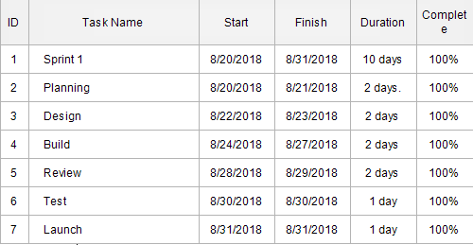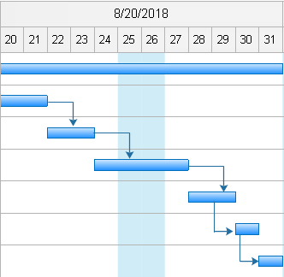

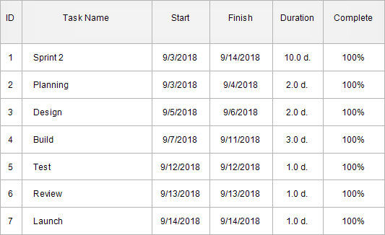 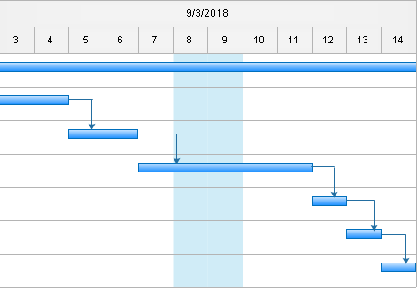

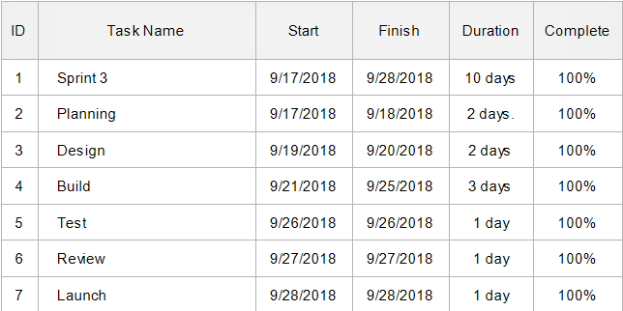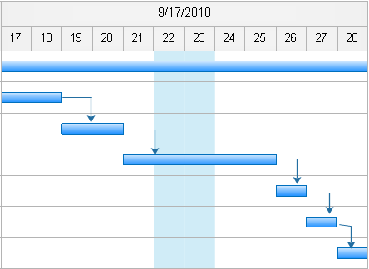

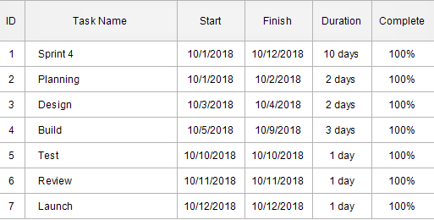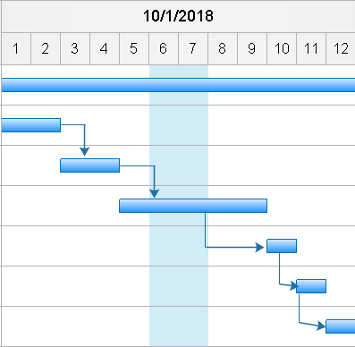

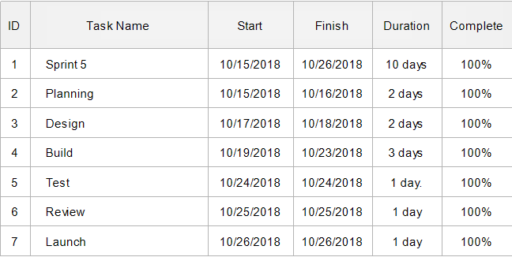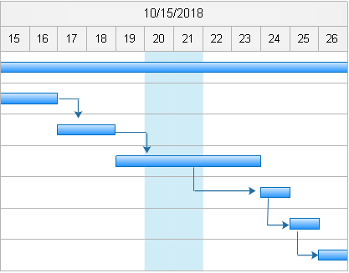

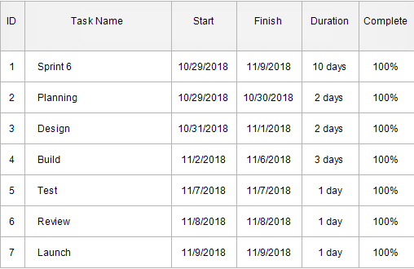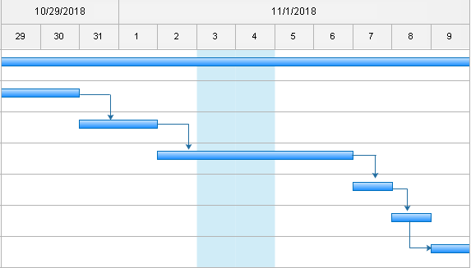

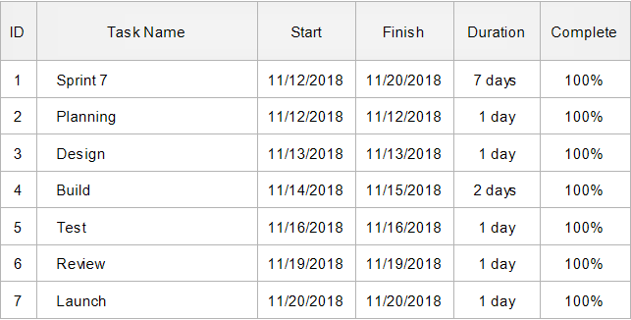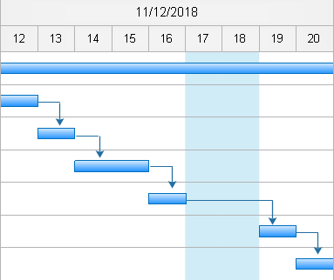

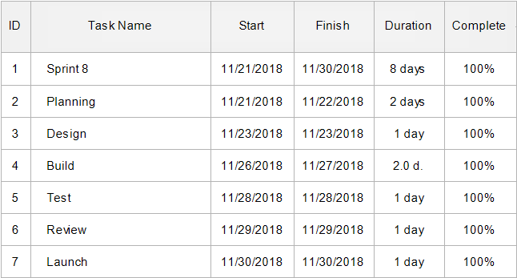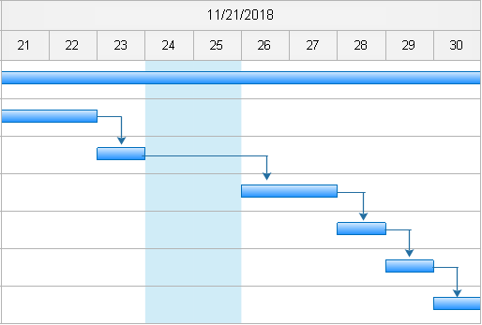



**Figure 2. The Gantt Chart of the Capstone Project**

Figure 2 shows the development time frame in processing the “ARAZGA: A Mobile Based Arabic Quiz Game Application”.

**Methods to be used in Developing the System**

Agile Software Development Methodology was developed to ensure satisfaction of the requirements among existing computerized system. It was a methodology construction to make sure that the requirements, planning, development and implementation, testing of the system follows logical approach and technical ways.

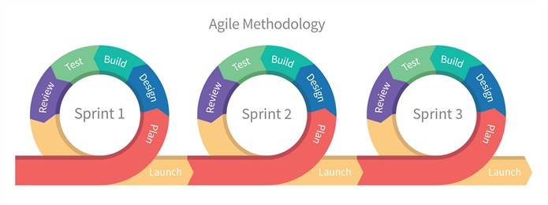

**Figure 3. Agile Software Development Methodology**

The researchers created a project title, formulated project objectives, scope and duration of the project. The researchers planned to develop the game entitled “ARAZGA: a Mobile Based Arabic Quiz Game Application”.

**Sprint 1 (Allow players to register)**

In sprint 1, the Researchers planned and pursued the objective One (1) which prompts them to design the registration for the player’s username. The researcher started to build the registration of the game and tested its functionality.

**Sprint 2 (Provide menus (Start, Instructions, Settings, Help, Leader Board, Exit)**

In sprint 2, the researchers will design and built the game menus; Start Instructions, Settings, Help, Leader board, and Exit and test its functionality.

**Sprint 3 (Manage configuration setting (Music/Sound. Background)**

In objective three (3) of the study, the researchers will design the settings of the game. The researchers determine the design that will suit for the game. The researchers downloaded music, icons, background, that would be needed in the game.

**Sprint 4 (Provide mode (Play Solo, Two Players)**

Sprint 4 was focused on the fourth objective of the stud which is to provide a mode for Solo and Two Players. The researchers design and built the mode of the game and test if it’s functioning.

**Sprint 5 (Set game categories (hadeeth, Seerah, Du’a, Qur’an)**

The researchers planned and designed the game categories which are the Hadeeth, Seerah, Qur’an and Dua. The researchers collected questions for every category. The researchers made sure that the questions used were true and very educational.

**Sprint 6 (Set game level (Easy, Average, Difficult)**

The researchers decided to set game levels. Game levels are easy, average and difficult. The researchers planned that the easy level could be a multiple choice format. Average level could be scramble words in which the players will form the letters to get the correct answer. While in the difficult level, it could be a word bank where the players would guess the answer and the top answer has the highest points. It is inspired of the game “Family Feud”.

**Sprint 7 (Provide help(50/50, coins)**

Sprint 7 is based on the seventh objective of the study. The researchers planned and designed the use of lifelines, which would add to the development of the game. Inspired by the game “Who wants to be a millionaire” these lifelines can only be used once every game. Then, the researchers designed and built the output of lifelines and tested its functionality.

**Sprint 8 (Provide leader board to show the top ranking players)**

Sprint 8 the researchers planned and designed the output of the leader board. The top ranking players will be displayed in the leader board. Then the researchers designed and built the output of the leader board and tested its functionality.

**Sprint 9 (Automatically declare the winner for the two player mode after the game)**

Sprint 9 was focused on the 9th objective of the study. Just like any other game, there would be a declaration for the winners for the two player’s mode. It would automatically declare the winner for the two player mode. The researcher designed and built it. After that, they test it’s functionality.

**Context Diagram**

**ARAZGA:**

**an**

**Arabic Quiz Mobile**

**Game Application**

PLAYER1

PLAYER2

Category

Host

Category

Leaderboard

Quiz

Connection

Game

Game

Level

Score

**Figure 4. Context Diagram**

Figure 4 shows the Context Diagram of the system.

**Physical Data Flow Diagram**

Input Name

Input Name

1.0

01.0

vet

**Player 1**

Select Start

Select Level

Set Game

Select Mode

Select Settings

Select Answer

Leader Board

Spiner Gale

Add Points

Select Level

Select Category

Select Play Solo

Change Background

Select Instructions

Text View

Text View

D1

D7

D4

D3

D2

Display Answer

2.0

1.5

Select Category

01.0

2.2

2.1

01.0

Select Answer

01.0

01.0

Select Difficulty

1.4

01.0

1.3

01.0

Select Play Solo

1.2

01.0

Enable Music

1.1

01.0

Select Start

Register name

Select Menu

Shared References

Score

Provide help

Result Display

Start

**Player 2**

***Continued…***

IP Address

D8

Connected

Select Host

**Player 2**

01.0

2.3

Manage Host

2.4

01.0

Select Client

Connected

Manage Connection

2.5

01.0

Select Category

Select Category

Spiner Gale

D9

Manage Category

**Figure 5. Physical Data Flow Diagram of the Study**

**Logical Data Flow Diagram**

Name

Name

1.0

01.0

vet

**Player 1**

Name

Level

Category

Mode

Settings

Select Answer

Leader Board

Spiner Gale

Points

Level

Category

Play Solo

Background

Instructions

Text View

Text View

D1

D7

D4

D3

D2

Display Answer

2.0

1.5

Select Category

01.0

2.2

2.1

01.0

Select Answer

01.0

01.0

Select Difficulty

1.4

01.0

1.3

01.0

Select Play Solo

1.2

01.0

Enable Music

1.1

01.0

Select Start

Register name

Menu

Shared References

Score

help

Result

Ready

**Player 2**

***Continued…***

IP Address

D8

Connection

Host

**Player 2**

01.0

2.3

Manage Host

2.4

01.0

Client

Connection

Manage Connection

2.5

01.0

Spiner Gale

D9

Category

Category

Manage Category

**Figure 6. Logical Data Flow Diagram of the Study**

The figure shows the logical data flow of the proposed study, which demonstrate the flow of the system.

**Entity Relationship Diagram**

tbl_player1

pk

Player1_id

Setting

Level

Category

tbl_player2

pk

fk

Player2_id

IP Address

Level

Category

tbl_score

pk

fk

score_id

name

easy

average

difficult

score

leaderboard

pk

fk

leaderboard_id

name

score

has

has

1...*

1..1

1..1

1...*

1...*

1..1

has

has

1..1

1...*

**Figure 7. Entity Relationship Diagram of the Study**

The figure 7 shows the entity relationship diagram of the proposed system entitled ARAZGA: a mobile based Arabic quiz game application. The figure demonstrate the relationship between the different entities such as tbl_player1, tbl_player2, tbl_score, leaderboard. All the table shown has a connector that shows the one to one relationship.